P EXPRESS Selective Mutism (SM) Communication Questionnaire - Adolescent/Adult

Date of birth: ___________________________ Level of Education ____________________

Gender: Female ______ Male ______

Please indicate languages spoken fluently: _____________________________________________________

Have you received a formal diagnosis of selective mutism? YES ____ NO ____ NOT SURE ____   
If yes, when were you diagnosed with SM (year ) __________ and by whom __________________.

Diagnosis, Symptoms, and Treatment:  
Have you ever received any other diagnosis (listed below)? If treatment was provided, list dates. Indicate any symptoms you have observed. Check all that apply.

|  |  |  |  |  |  |  |  |  |  |  |  |  |  |  |  |  |  |  |  |  |  |  |  |  |  |  |  |  |  |  |  |  |  |  |  |  |  |  |  |  |  |  |  |  |  |  |  |  |  |  |  |  |  |  |  |  |  |  |  |  |  |  |  |  |  |  |  |
| --- | --- | --- | --- | --- | --- | --- | --- | --- | --- | --- | --- | --- | --- | --- | --- | --- | --- | --- | --- | --- | --- | --- | --- | --- | --- | --- | --- | --- | --- | --- | --- | --- | --- | --- | --- | --- | --- | --- | --- | --- | --- | --- | --- | --- | --- | --- | --- | --- | --- | --- | --- | --- | --- | --- | --- | --- | --- | --- | --- | --- | --- | --- | --- | --- | --- | --- | --- |
| |  |  |  |  | | --- | --- | --- | --- | |  | Year  Diagnosed | Received Treatment | List Symptoms | | Special Needs (education,  assistance, etc.) |  |  |  | | Speech-Language Impairment |  |  |  | | Sensory Sensitivity (food, touch,  smell, hearing, vision, etc.) |  |  |  | | Auditory Processing Issues |  |  |  | | Learning Disorder/Difference |  |  |  | | Anxiety Disorder |  |  |  | | Depression |  |  |  | | Attention Deficit/Hyperactivity Disorder |  |  |  | | Asthma |  |  |  | | Autoimmune Disorder |  |  |  | | Drug or Alcohol Dependency |  |  |  | | High Blood Pressure |  |  |  | | Chronic Pain |  |  |  | | Other Medical Condition |  |  |  | | Other Medical Condition |  |  |  | |  |  |  |
|  | |  |  |

When did you first become aware of your mutism? __________________(age)   
In what situation(s) was/is your mutism noticed? ______________________________________________________________________________________________________________________________________________________  
______________________________________________________________________________________________________________________________________________________  
Please describe how you feel around different people at home.

______________________________________________________________________________________

______________________________________________________________________________________

Please describe how you feel around different people at work or school.

_____________________________________________________________________________________

______________________________________________________________________________________

Please describe how you feel around different people in public places.

______________________________________________________________________________________

_____________________________________________________________________________________

Is there a history of social anxiety, other anxiety problems, or phobias in the immediate or extended family? YES ____ NO ____ If yes, please explain:

In the box below, please describe what you might say or do to help yourself communicate in various settings (at home, in work/school, and in public places).

Home:  
________________________________________________________________________________  
  
_________________________________________________________________________________  
  
_________________________________________________________________________________

Work/School:  
_________________________________________________________________________________  
  
_________________________________________________________________________________  
  
_________________________________________________________________________________  
  
Public Places:  
_________________________________________________________________________________  
  
_________________________________________________________________________________  
  
_________________________________________________________________________________

Communication in various settings:

*On next page:* In the three settings listed on the chart below (home, work/school, and public

places), please indicate how you communicate with those listed. Write a sentence or two to describe the ways in which you communicate with others. In situations where you have had no opportunity to meet and interact with those people or situations listed below, write NA for “Not Applicable.” Also, check off whether you respond (answer) and/or initiate (ask or start a conversation).   
Please note whether you whisper, speak in single words, use sentences, or engage in spontaneous extended conversation. If not speaking in a situation, note if gestures are used or writing/texting is the main way of communicating in those situations listed.

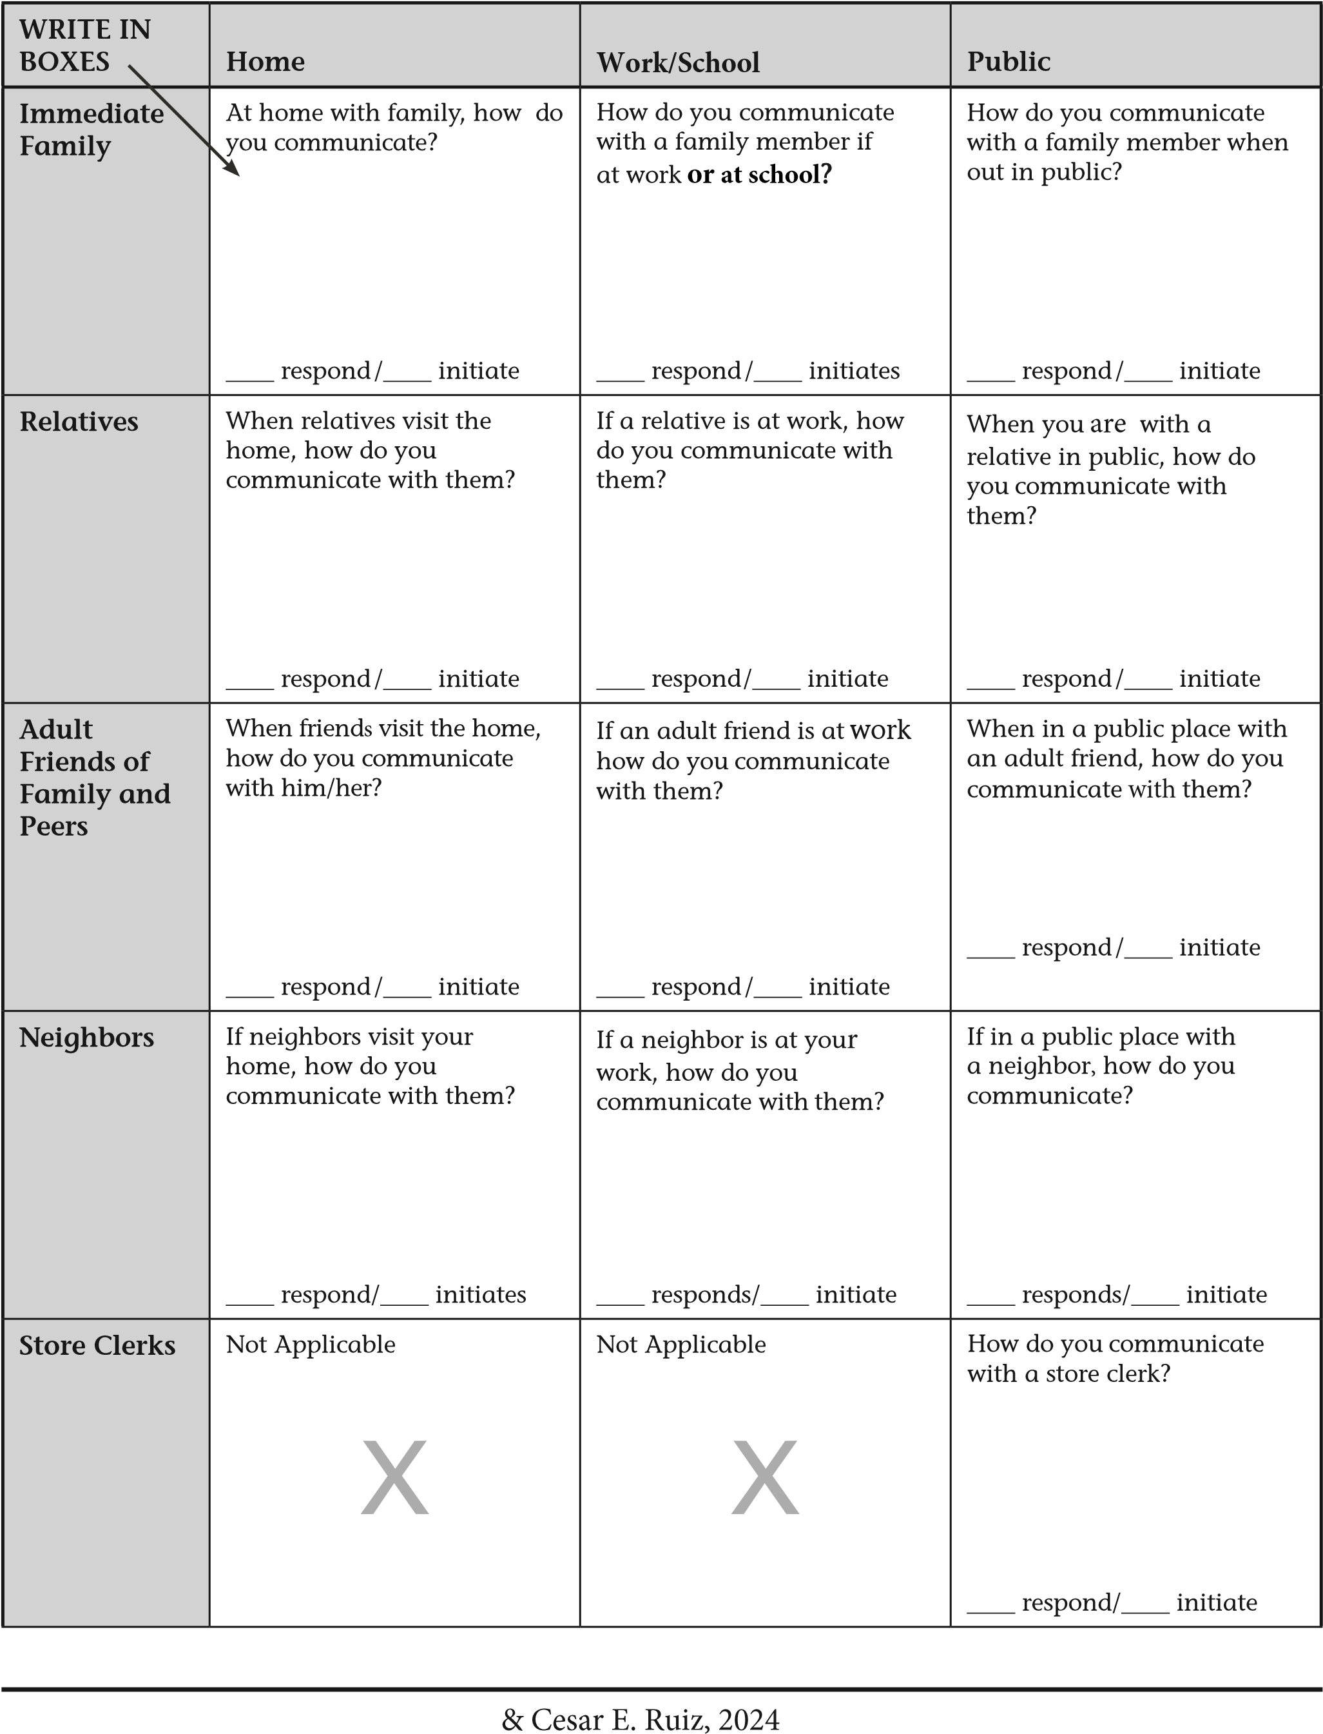

|  |  |  |  |
| --- | --- | --- | --- |
| WRITE IN BOXES | Home | Work/School | Public |
| Servers | Not Applicable X | Not Applicable X | How do you communicate with a server at a restaurant?  ____ respond /____ initiate |
| Doctors/  Helping  Professionals | If a helping professional (such as a therapist or counselor, etc.) worked with you at home, how would you communicate?    ____ respond /____ initiate | If a helping professional  (such as nurse, counselor, etc.) is working with you at your work or school, how do you communicate?  ____ respond /____ initiate | How do you communicate with a doctor or other helping professional at their office?  ____ respond/____ initiate |
| Peers | When a peer visits your home, how do you communicate with them?  ____ respond /____ initiate | How do you communicate with peers at work or school?  ____ respond /____ initiate | When in a public place with a peer, how do you communicate?  ____respond/____ initiate |
| Coworkers | If a coworker(s) visits your home, how do you communicate with them?  ____ respond /____ initiate | How do you communicate with coworkers at work when alone or in a group?    ____ respond /____ initiate | How do you communicate with coworkers at work when alone or in a group?    ____ respond /____ initiate |
| Others | ____ respond /____ initiate | ____ respond /____ initiate | ____ respond /____ initiate |

How do you communicate in various settings when someone you trust and feel comfortable with is there compared to when they are not there? Please describe.

How do you communicate on the phone with anyone who may call? Please describe.

How do you like your work and/or school if attending? Please describe.

Have you ever received any type of treatment/therapy/medication for selective mutism? If yes, please describe and explain your progress and difficulties.

As best you can, please provide an overview of your selective mutism and any information you believe important to share. In doing so, please provide details of your social world and communication skills and difficulties. Include anything about talking including what helps or what is difficult.